|  |
| --- |
| Vicenary Games |
| Space Shooterz |
| **C:\Users\Karem\AppData\Local\Microsoft\Windows\INetCache\Content.Word\TeamLogo.jpg** |
| Version #1  All work Copyright © 2019 by Vicenary Games.  All rights reserved. |
| **Abdulkarem Alani** |
|  |

|  |
| --- |
| October 5th 2019 |

**Table of Contents**

Contents

**Version History** 3

Game Overview 4

Controls 4

Interface Sketch 4

Menu and Screen Descriptions 5

Game World 6

Characters 6

Non-player Characters / Enemies 6

Scoring 7

Sound Index 7

Art / Multimedia Index 7

# **Version History**

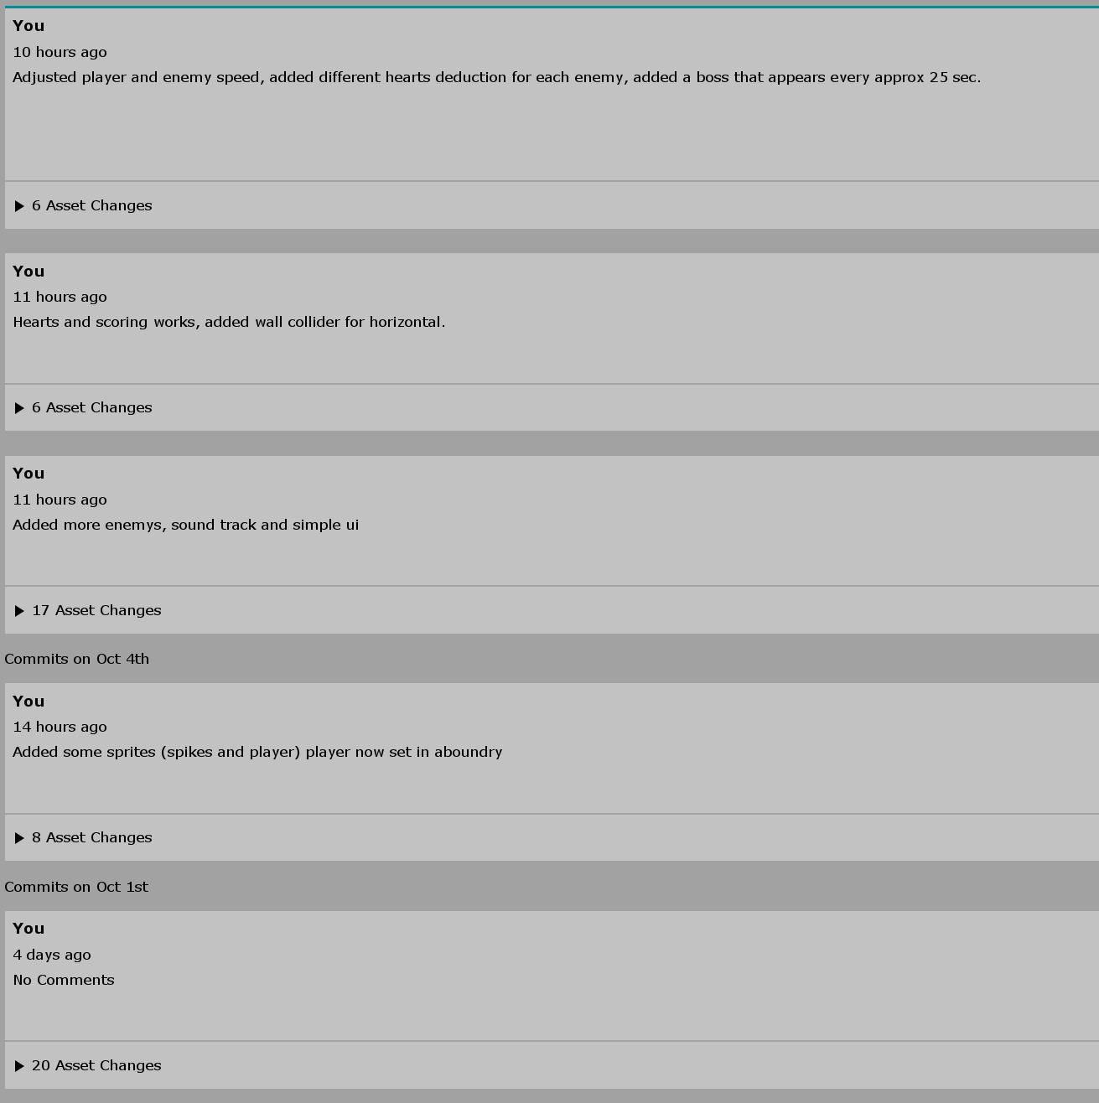

[This is the body of your video game design document. You should add and delete sections as they pertain to your game’s design.]

# Game Overview

*The goal of the game is to avoid hitting the space ship and collect the rocks for a higher score with only 20 hearts, there are 4 types of spaceships and each one looks and damages the player differently.*

# Controls

Use WASD to move or even the arrow keys.

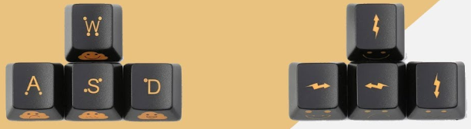

# Interface Sketch

*(What does the game interface look like? Provide a screen shot or sketch)*

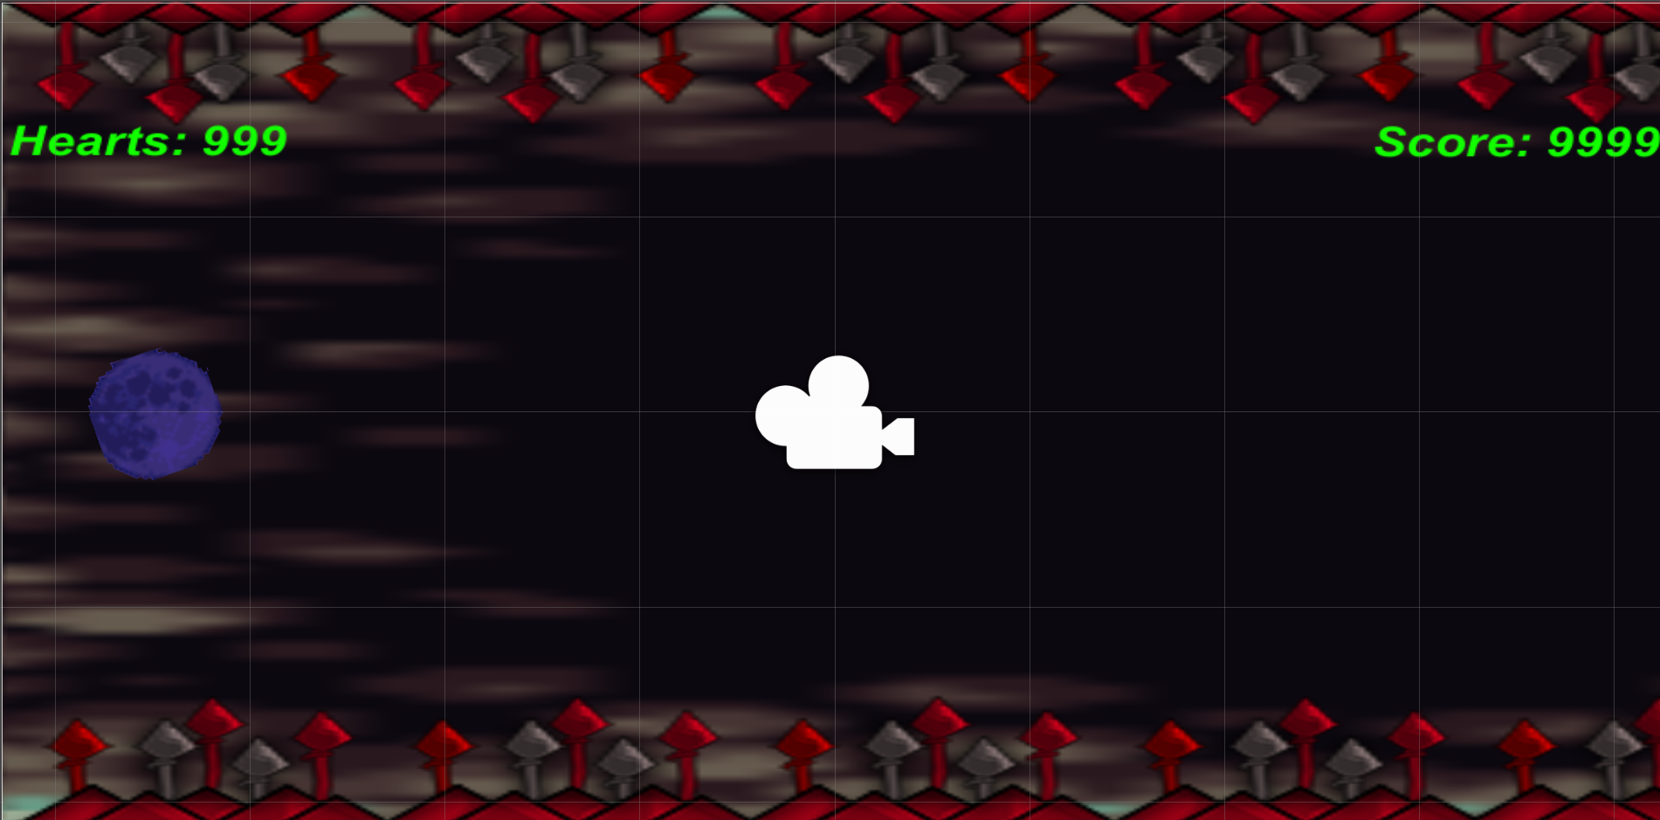

# Menu and Screen Descriptions

*(Include additional screen shots and accompanying descriptions for any menus and additional screen)*

*Start screen:*

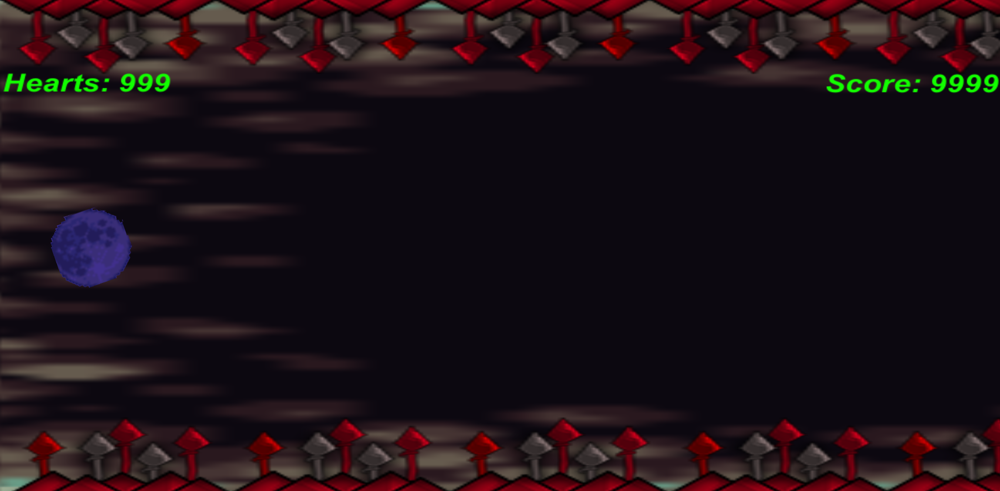

*Playing:*

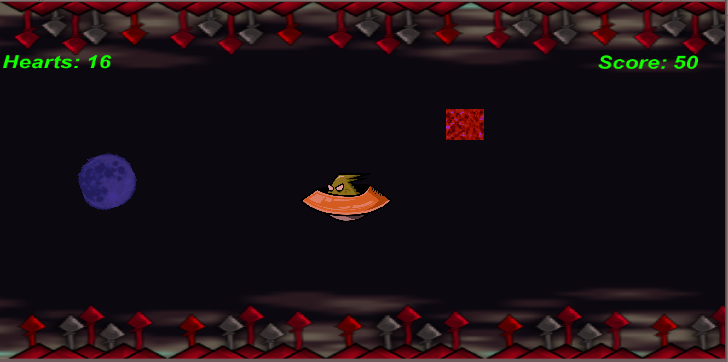

*Boss/End:* 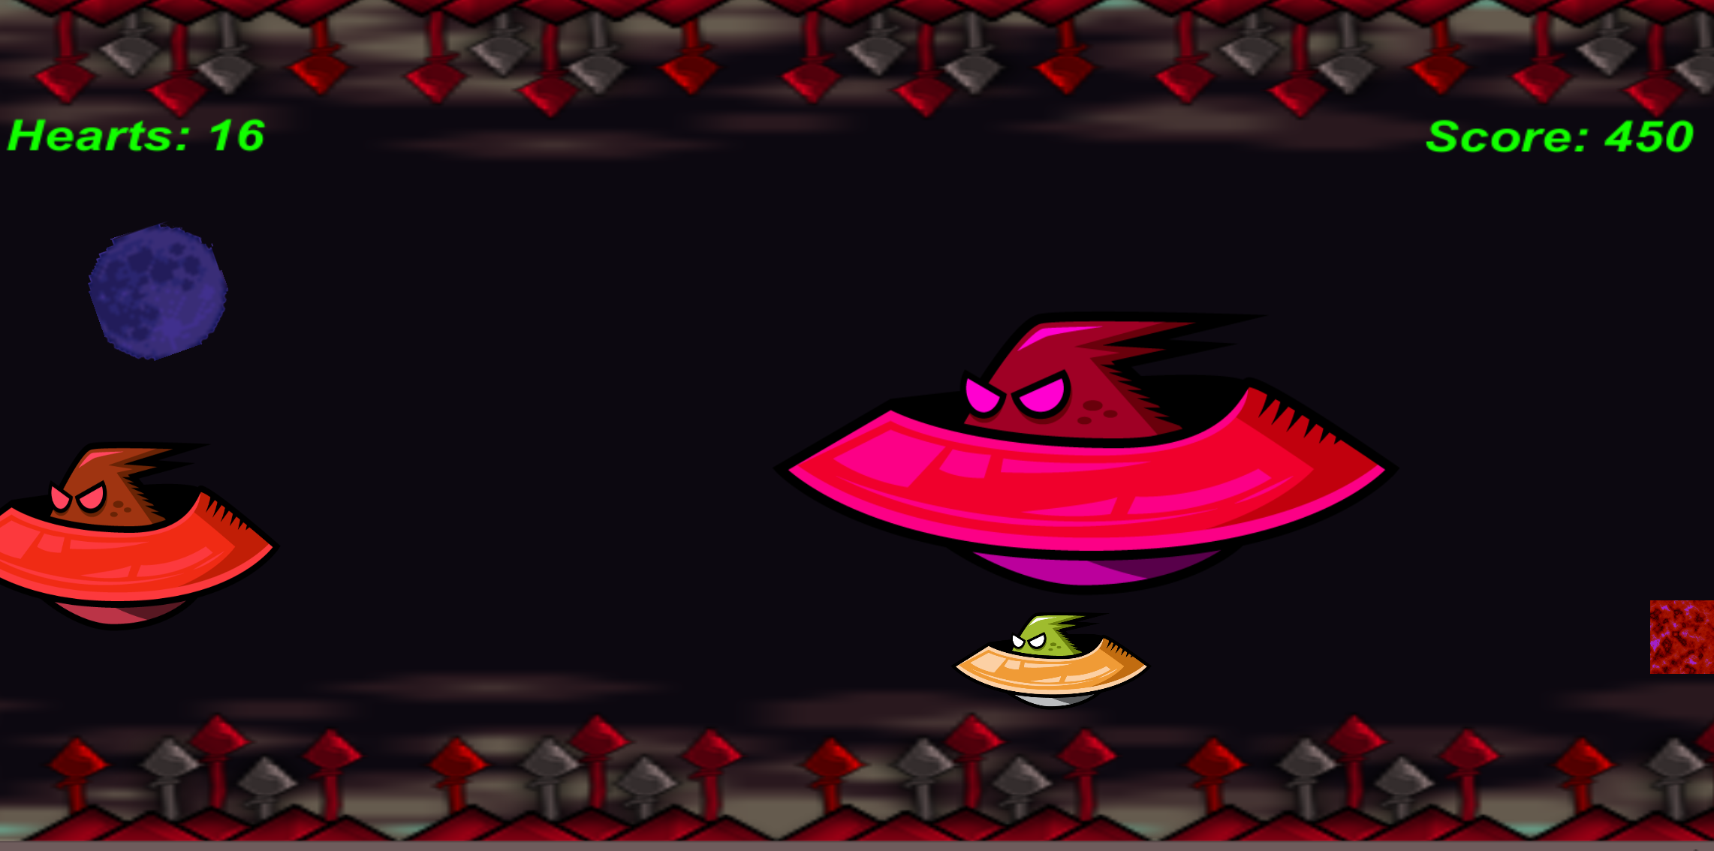

# Game World

*A Player (Moon) in space trying to avoid spaceships from hurting it and trying to collect stones to increase the score.*

# Characters

Player will be playing as a start (moon):



# Non-player Characters / Enemies

Randomly placed spaceships that scroll from right->left, trying to damage the player.

* Yellow enemy will subtract one of the player’s heart.
* Orange enemy will subtract two of the player’s heart.
* Red enemy will subtract three of the player’s heart.
* Purple enemy will subtract ten of the player’s heart, spawns after approx. 25-30 sec.

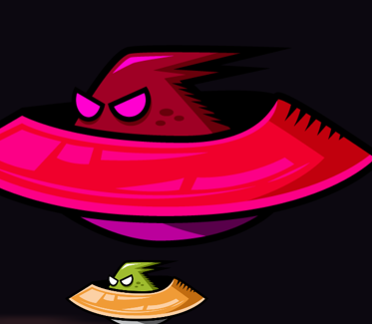

# Scoring

Every time the player successfully touch a stone the score will be increasing by 50 points.

# Sound Index

* *Sound track starts when the game is launched*

# Art / Multimedia Index

*(Include an index of all your graphic and video assets here)*

**Background:**

*[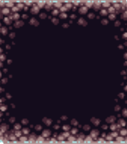](../Desktop/Shooterz_Assignmnet_1/Assets/Assets/Ground.PNG)*

***Lava Stone:***

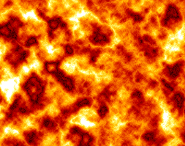

***Player:***



*Obsticle(Spikes):*

**

*Enemy UFO:*

**